83.12.00
To George Doughty Jr
RB MSS M106, Library, Royal Botanic Gardens Melbourne.

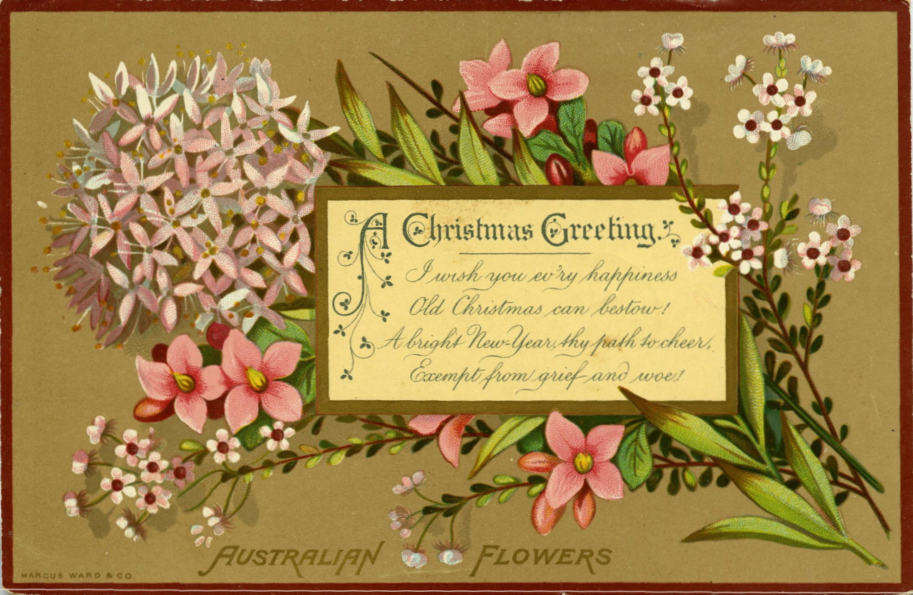

A Christmas Greeting.
I wish you ev'ry happiness
Old Christmas can bestow!
A bright New Year, thy path to cheer,
Exempt from grief and woe!

AUSTRALIAN FLOWERS

To George F. St. H. Doughty
from his uncle
Ferd. von Mueller
Christmas
1883.

MS is a card showing a smaller card with the printed greetings lying on a bunch of Australian wildflowers: 83-12-00_image01.jpg M's greeting is on the reverse.

